**PRACTICAL: 1**

**AIM:**

A security training institute is setting up a lab for ethical hacking workshops. The team must decide whether to use Kali Linux or Parrot Security OS, prioritizing ease of installation, hardware requirements, and post-installation configuration for beginner and intermediate students. Evaluate and install the most suitable penetration testing operating system for a security team by exploring the installation processes and user-friendliness of Kali Linux and Parrot Security OS.

**THEORY:**

Kali Linux *(formerly known as Backtrack Linux)* is an open-source, Debian-based Linux distribution which allows users to perform advanced penetration testing and security auditing. It runs on multiple platforms and is freely available and accessible to both information security professionals and hobbyists.

This distribution has [several hundred tools, configurations, and scripts](https://www.kali.org/features/) with [industry-specific modifications](https://www.kali.org/docs/policy/penetration-testing-tools-policy/) that allow users to focus on tasks such as computer forensics, reverse engineering, and vulnerability detection, instead of dealing with unrelated activities.

Parrot Security (ParrotOS, Parrot) is a Free and Open source GNU/Linux distribution based on Debian Stable designed for security experts, developers and privacy aware people.

It includes a full portable arsenal for IT security and digital forensics operations. It also includes everything you need to develop your own programs or protect your privacy while surfing the net.

**CODE:**

|  |
| --- |
| **N/A** |

**OUTPUT:**

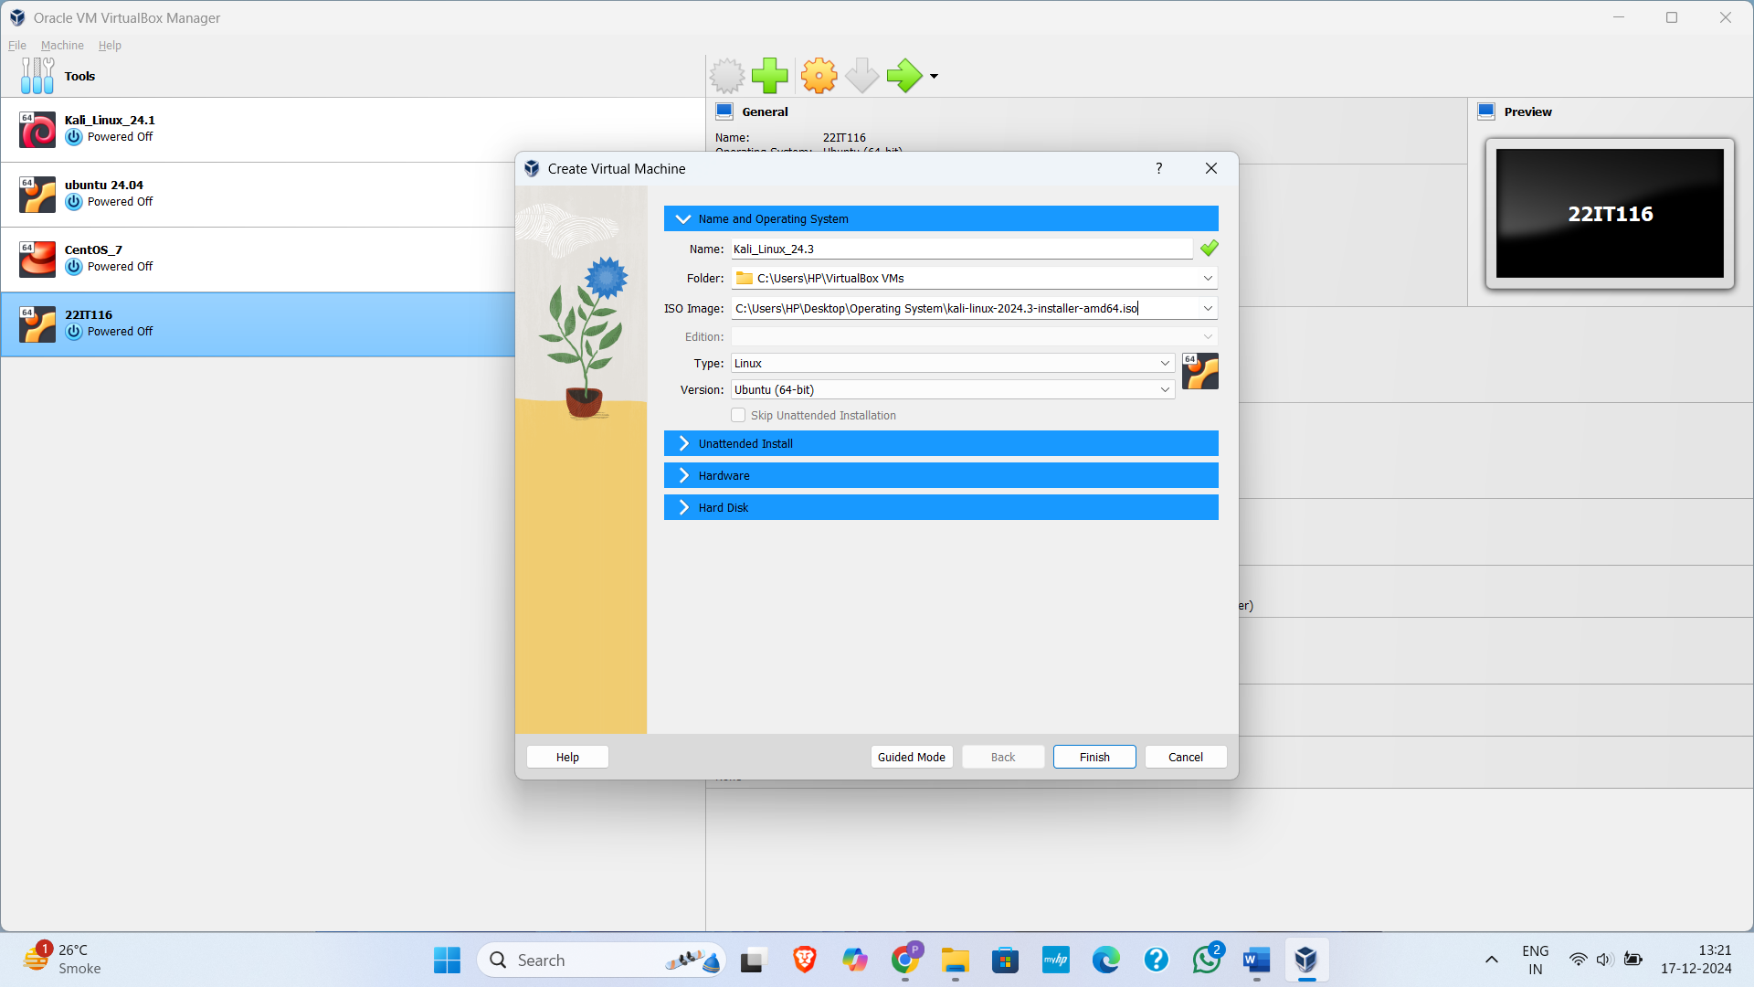

Figure 1: Set the name of your virtual machine and provide iso image

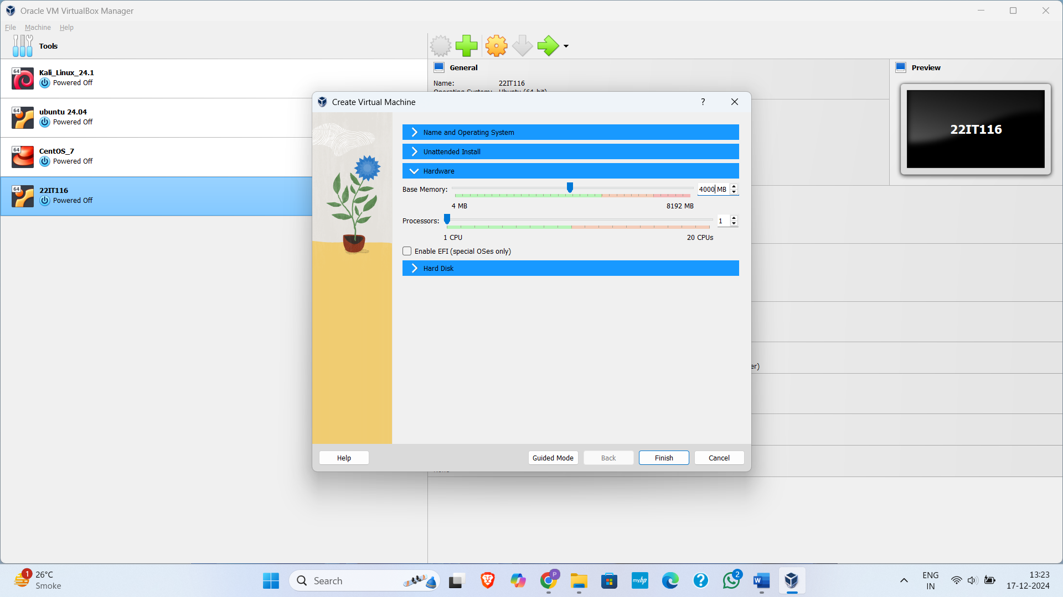

Figure 2:Provide RAM to your VM

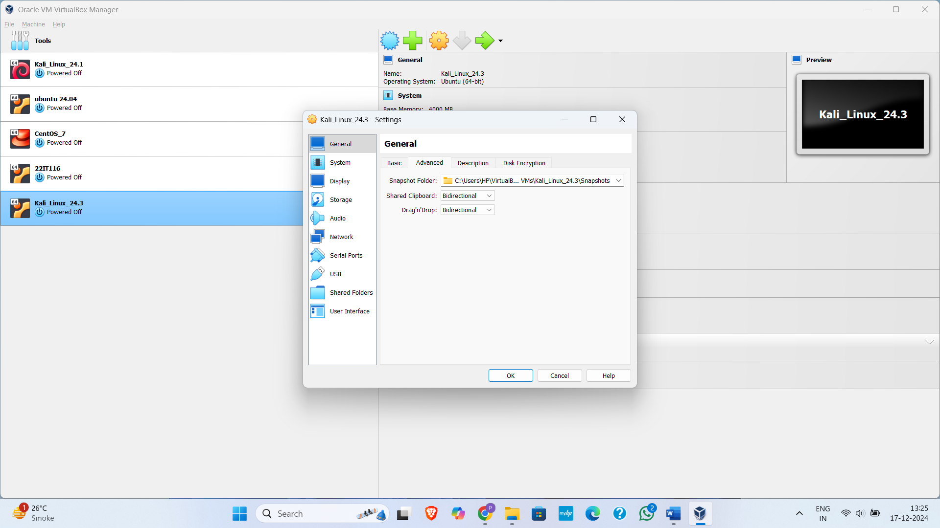

Figure 3: Set Clipboard bidirectional

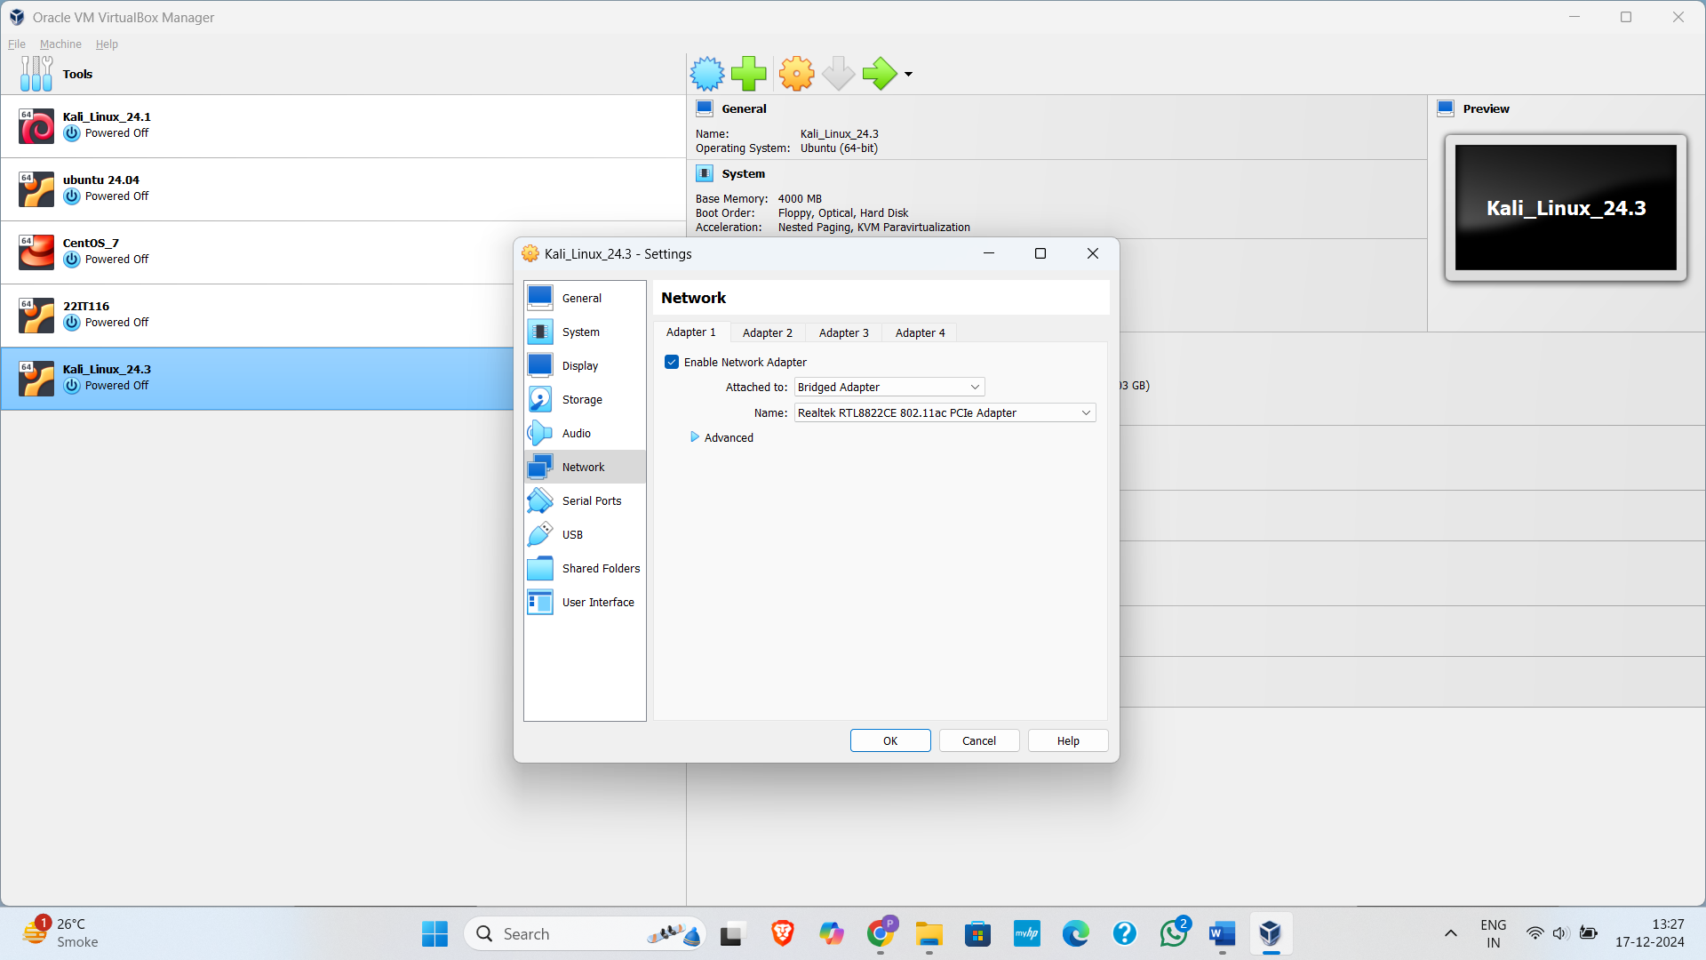

Figure 4: Set network to Bridged adapter

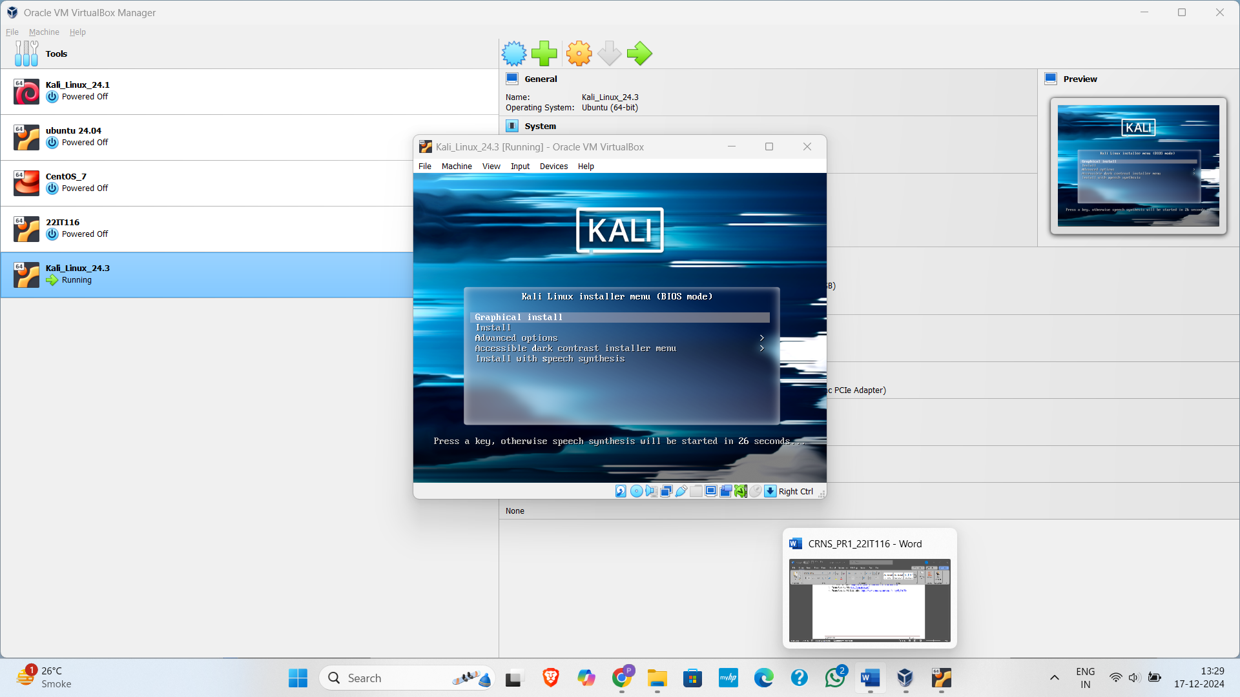

Figure 5:Run VM and install Graphical interface

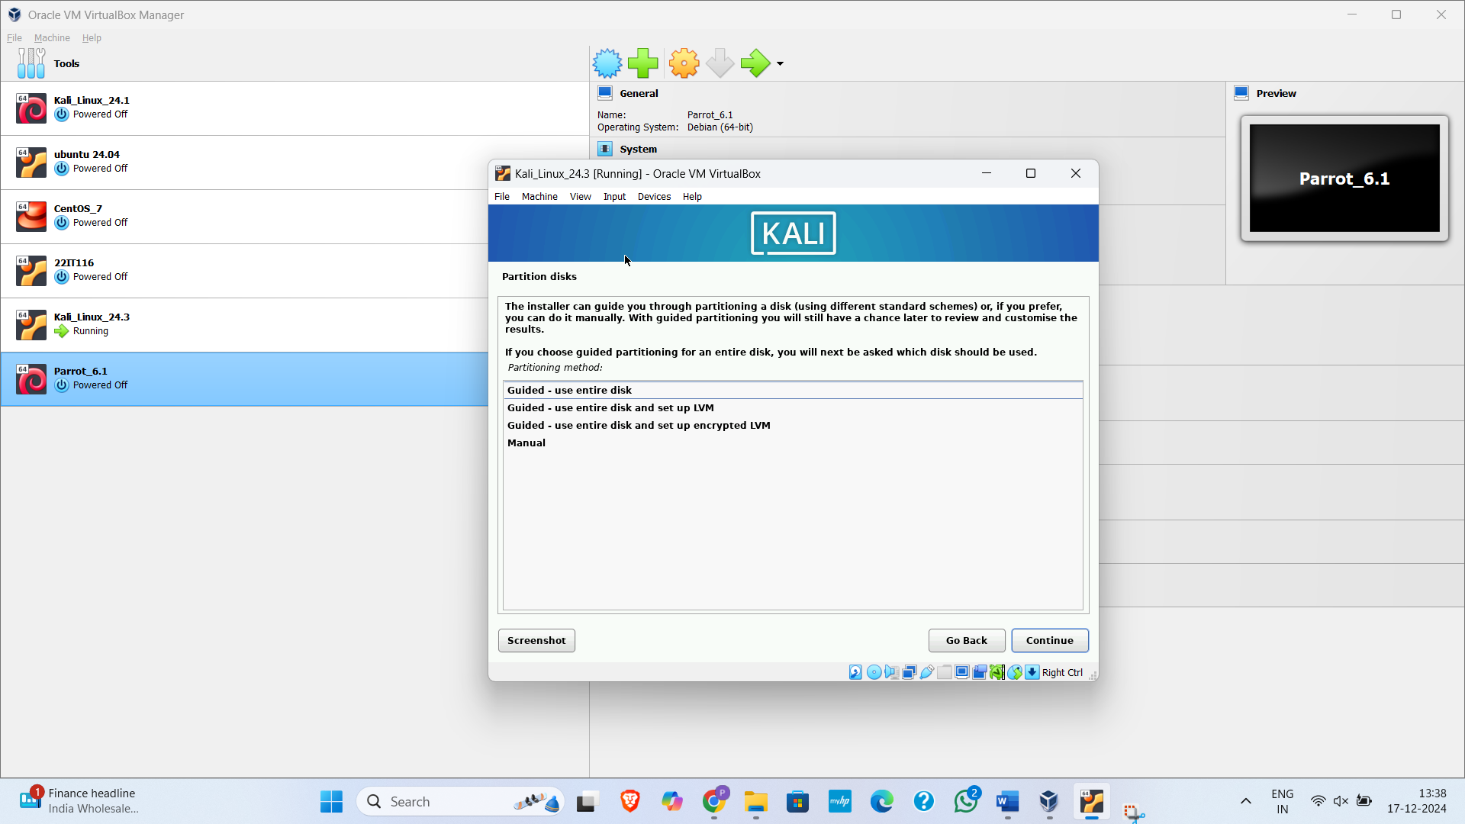

Figure 6:Use entire Disk partition disk

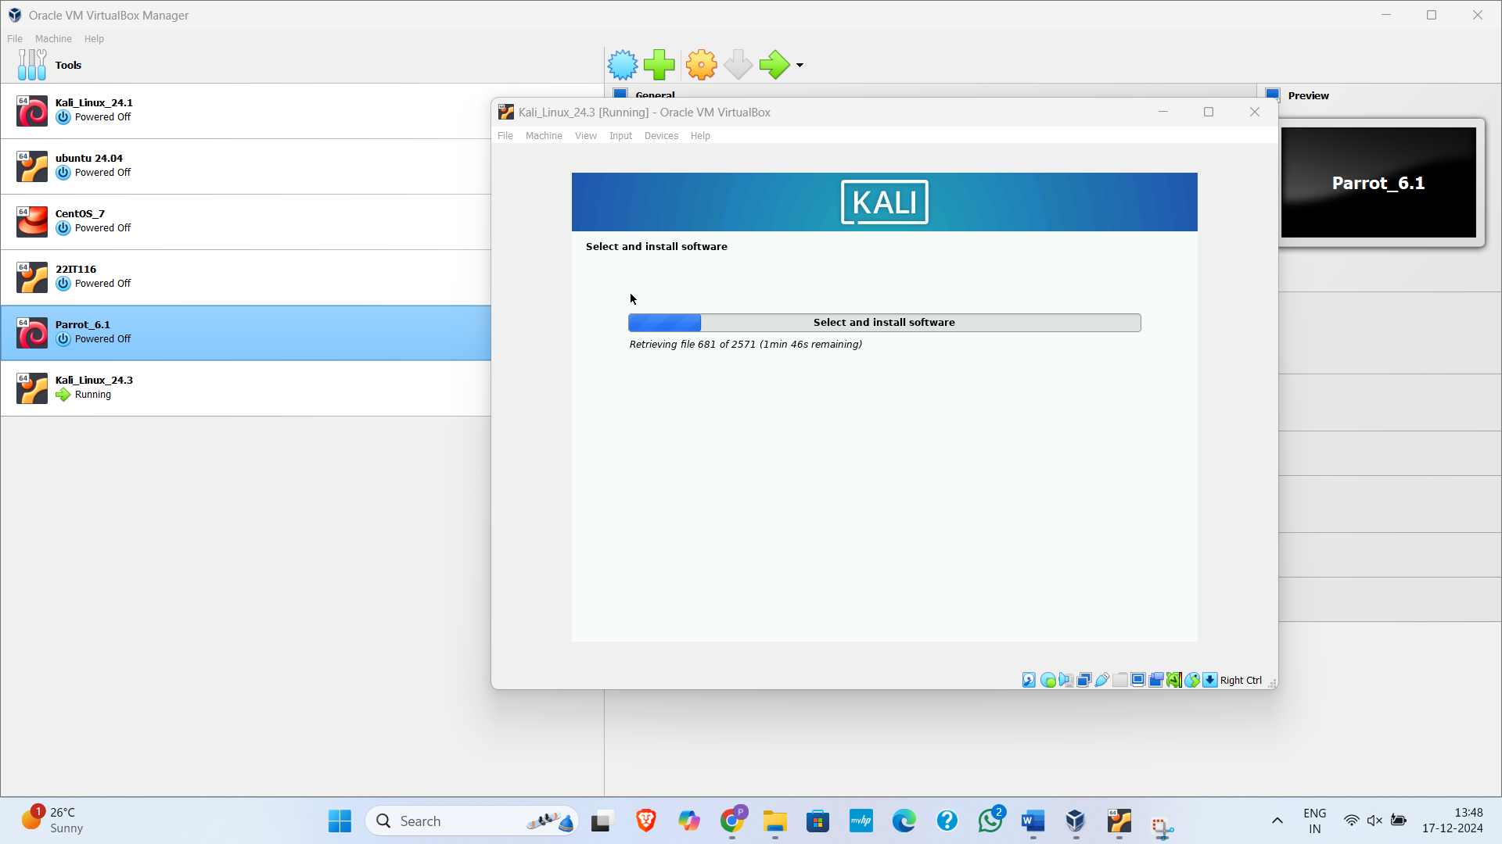

Figure 7:Install software

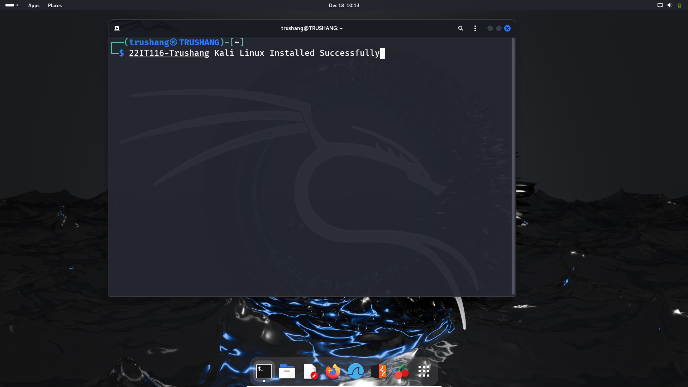

Figure 8: Kali Linux Installed Successfully

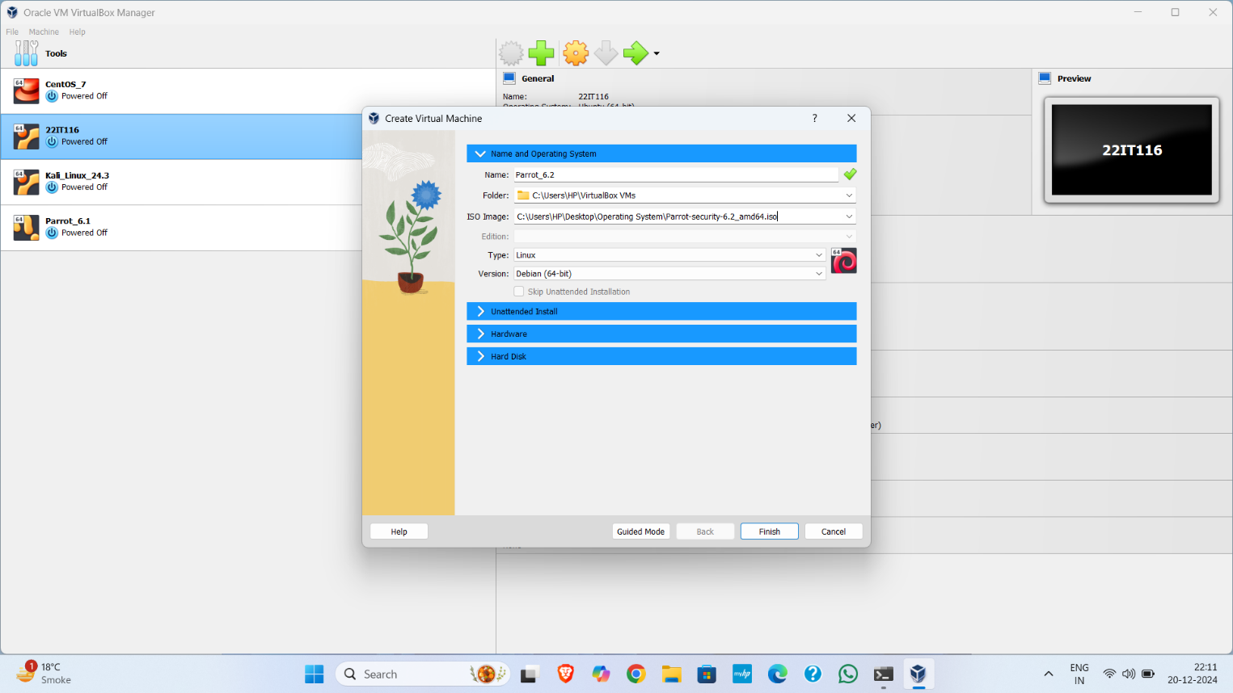

Figure 9:Set the name of your virtual machine and provide iso image

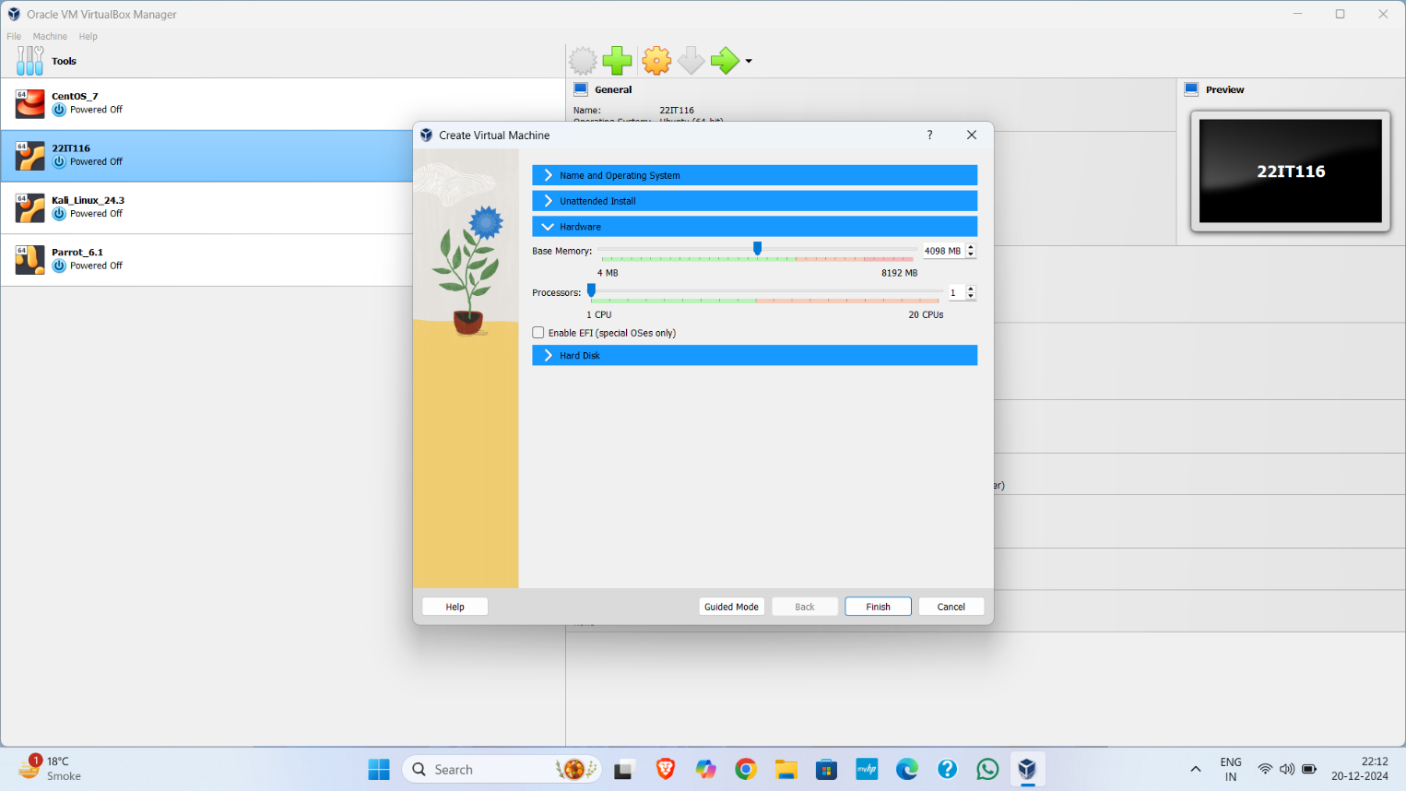

Figure 10:Provide RAM to your VM

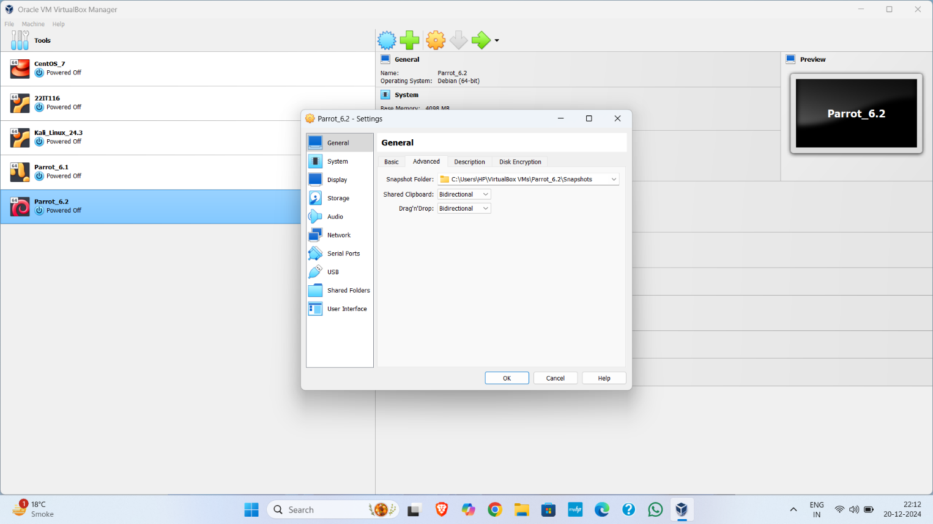

Figure 11:Set Clipboard bidirectional

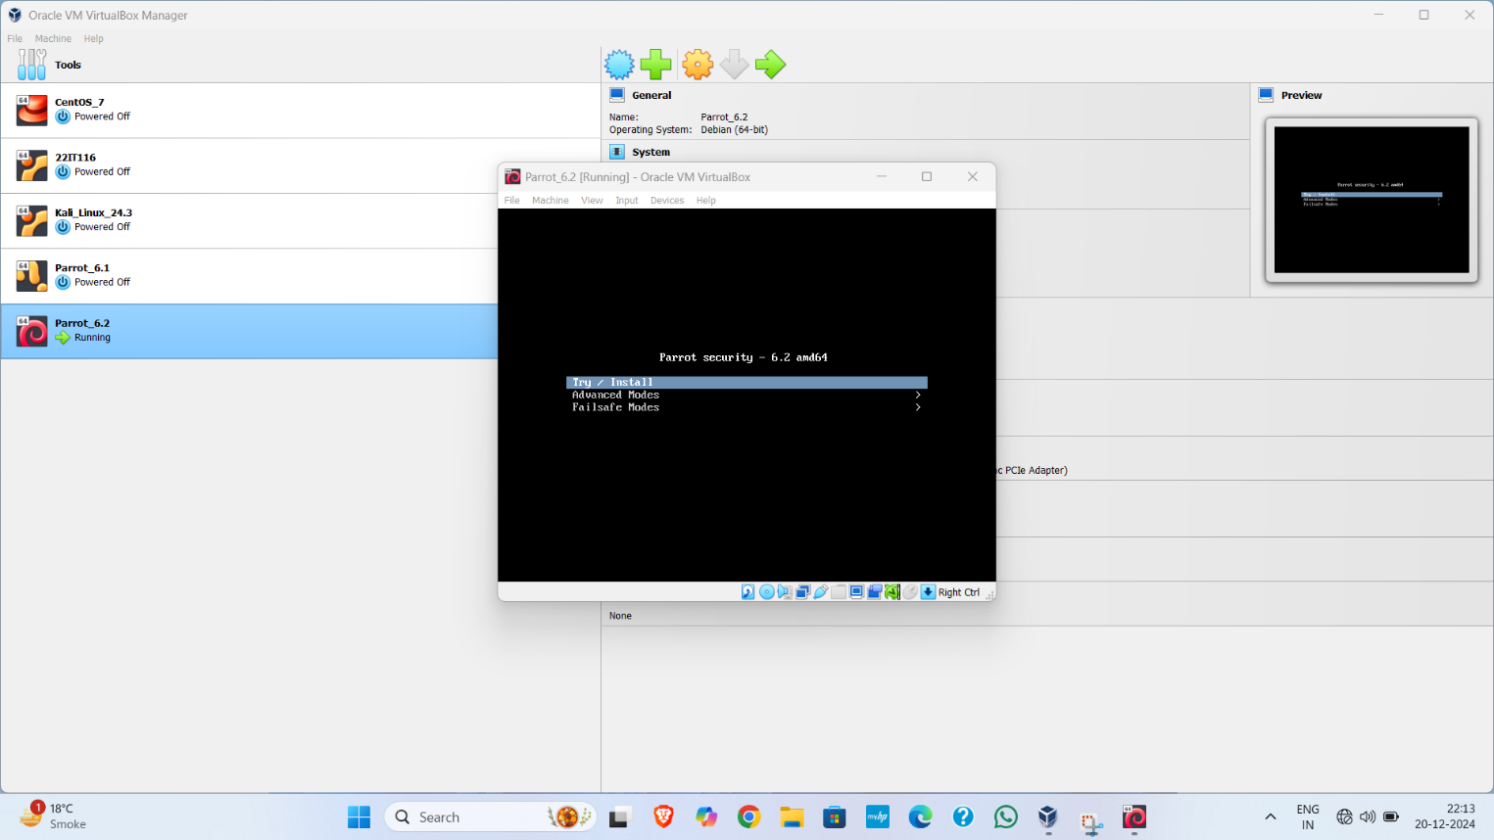

Figure 12:Install parrot

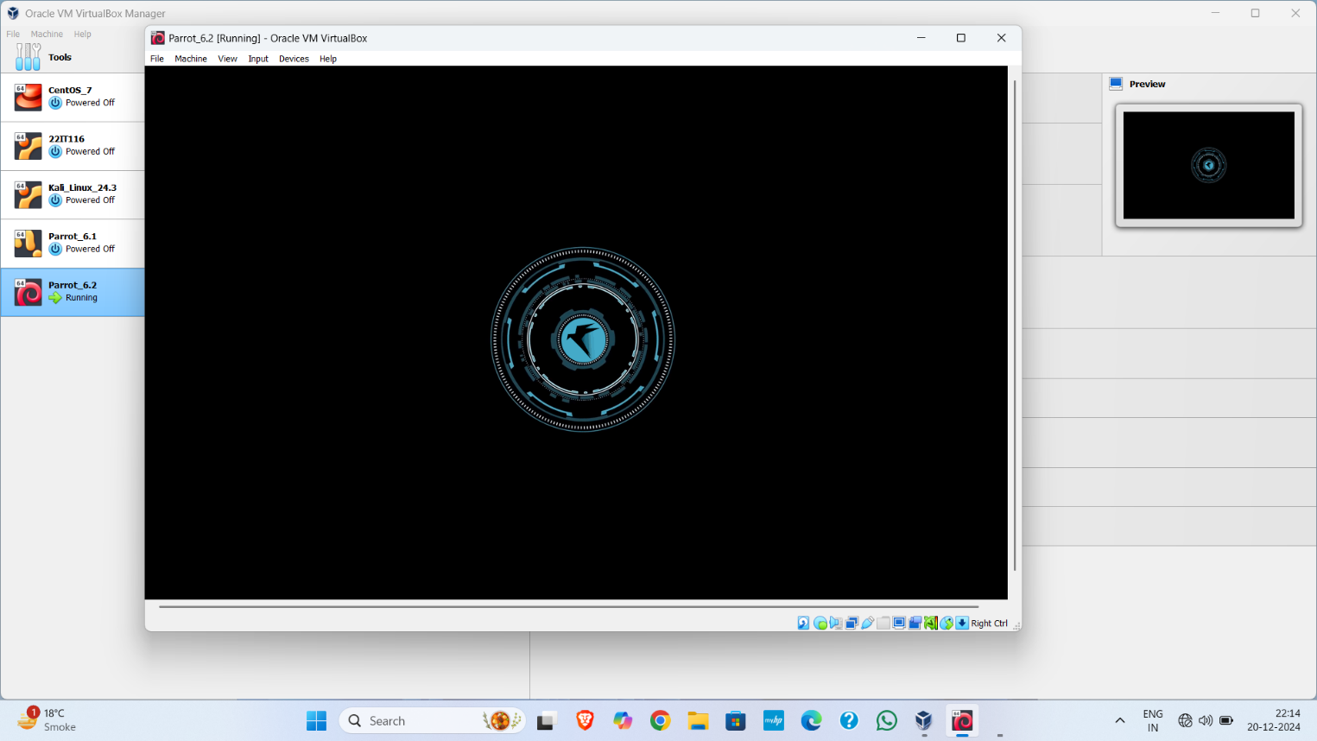

Figure 13: Starting Parrot

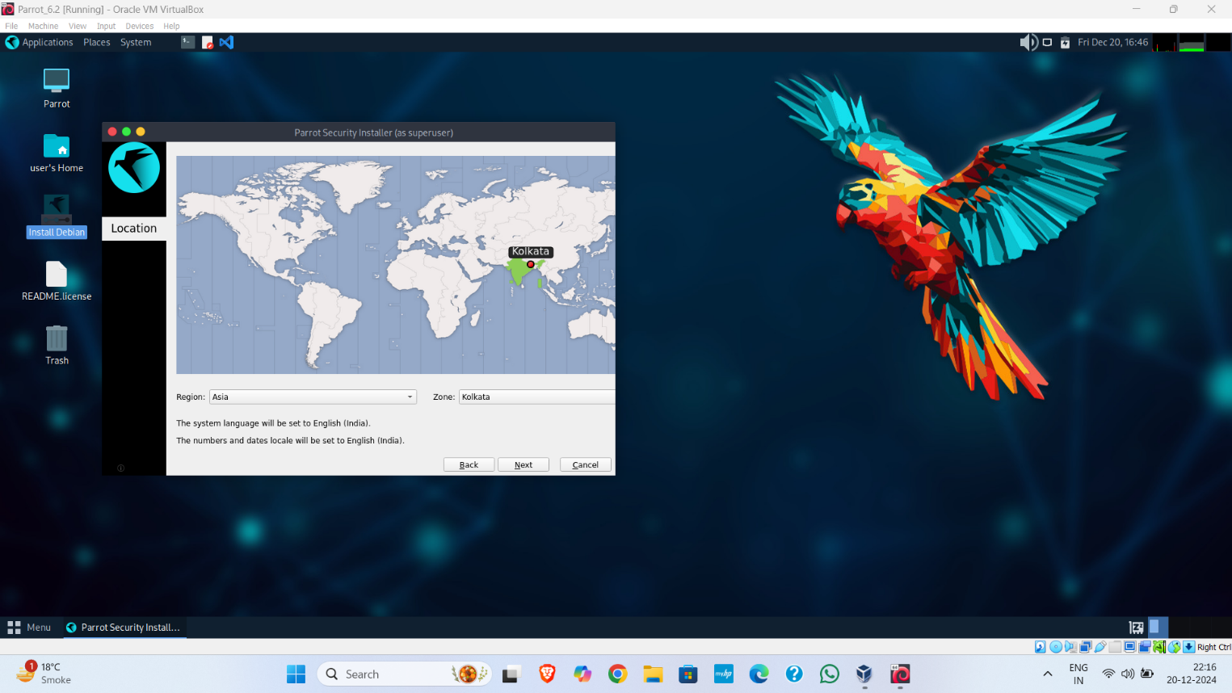

Figure 14: Set Location

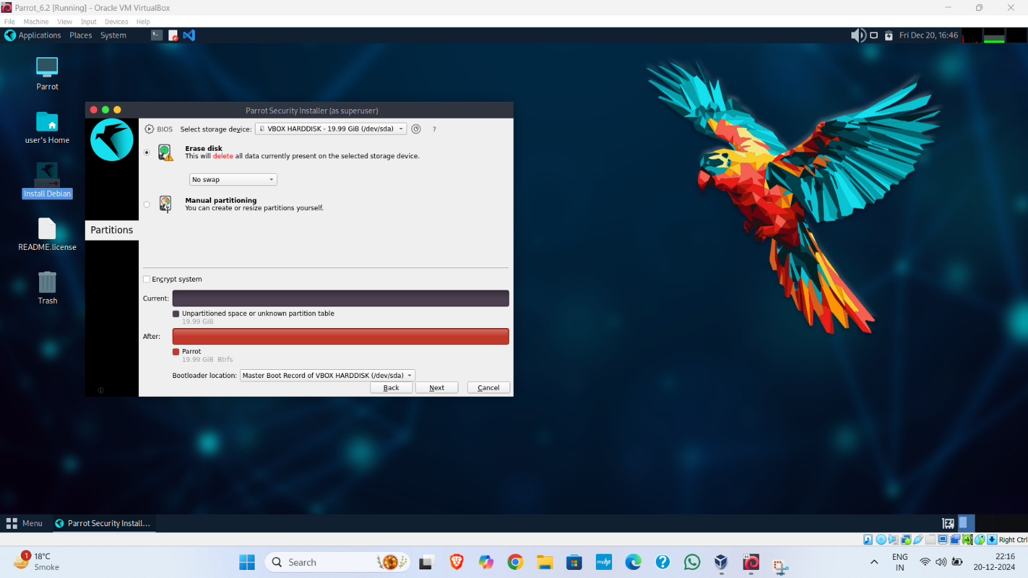

Figure 15 : Set partition

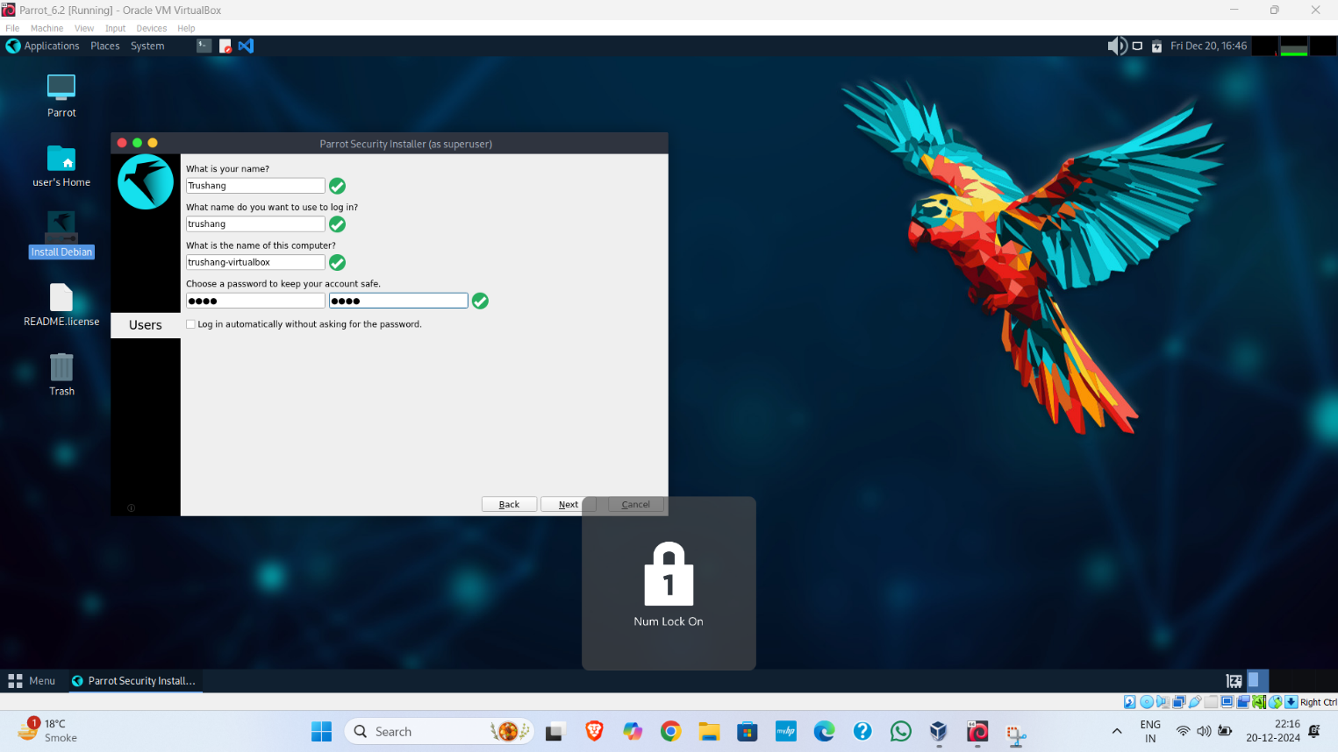

Figure 16: Create user name and password

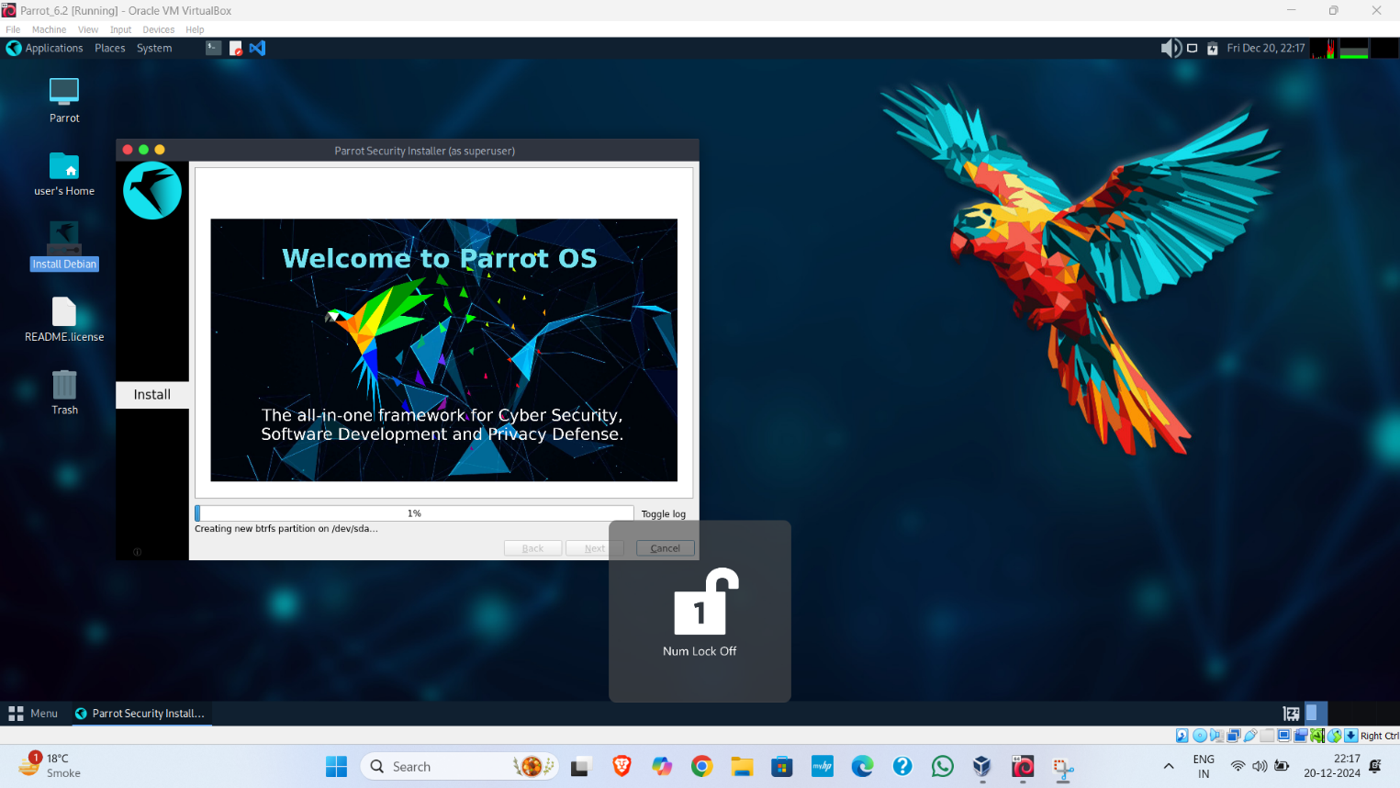

Figure 17: Started installing Parrot OS

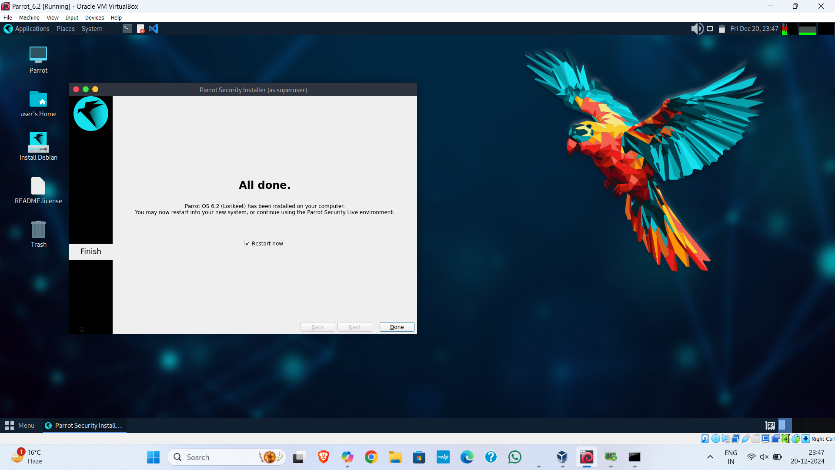

Figure 18: Complete installation of Parrot security OS

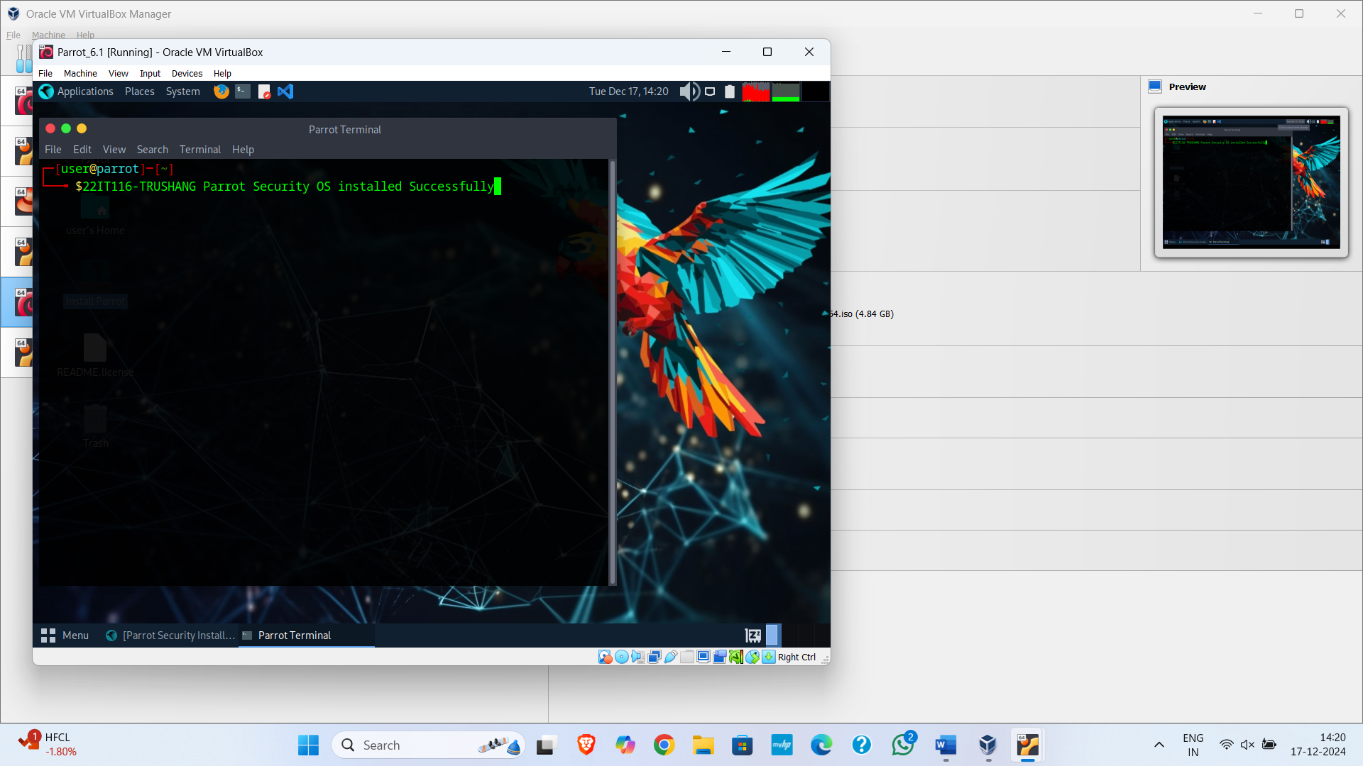

Figure 19: Final screenshot of install parrot

**LATEST APPLICATIONS:**

Kali Linux:

* Penetration Testing and Ethical Hacking
* Red Team Operations
* Forensics
* Cloud Security

Parrot security OS:

* Cryptography and Encryption
* Forensics and Digital Investigation
* Red and Blue Team Activities
* Web Application Security

**LEARNING OUTCOME:**

In this practical, we learn how to install Kali Linux and Parrot security OS in VM. We compare kali Linux and parrot security OS, Kali Linux is best for penetration testing and offensive security, offering a comprehensive suite of tools for ethical hackers. Parrot Security OS is ideal for privacy, digital forensics, and defensive security, providing a well-rounded platform for security professionals

**REFERENCES:**

1. Kali OS: <https://www.kali.org/>
2. Kali OS Installation: <https://www.youtube.com/watch?v=jk2KGdJU2OI>
3. Parrot Security OS: <https://parrotsec.org/>
4. Parrot Security OS Installation: <https://www.youtube.com/watch?v=4qvFp99rfXw>